4 July 2018

Andrew Goodall
Director General - Health and Social Services, NHS Wales
Welsh Government
Cathays Park
Cardiff
CF10 3NQ

Nicholson House
Lime Kiln Close
Stoke Gifford
BRISTOL BS34 8SR
Telephone 0117 931 7137

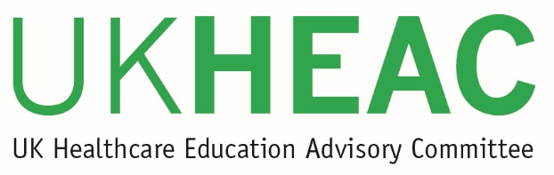
Dear Andrew

UK Healthcare Education Advisory Committee update

The UK Healthcare Education Advisory Committee (UKHEAC) met on 12 June 2018. This letter summarises key items of discussion and feedback arising from that meeting for the benefit of system leaders in healthcare education. A similar letter is being sent to appropriate policy bodies in each of the UK nations.

Following discussion and input on health higher education in the devolved nations, members discussed the importance of recognising divergence of practice across the UK and the potential effect this can have on the future UK workforce. Members agreed it is important to ensure that any cross border impacts arising from changes or developments to the HE system of one nation should be fully explored where possible. Members support taking a UK wide view of the health system with regard to outcomes and suggested that more opportunities for dissemination of good practice between nations should be sought, particularly as nations are experiencing different levels of success in addressing the challenges of recruitment to specialised health courses.

The latest data on recruitment to nursing, midwifery and allied health was discussed. Members noted the overall decline in UK applications, recognising that the problems vary from profession to profession and region by region, with the national figures masking different approaches in the devolved administrations and some more acute subject and regional concerns, for example in fields such as Learning Disability Nursing, Podiatry and Therapeutic Radiography.

The issues facing clinical academics were discussed by the Committee, with members recognising the challenges in the system from an older and declining clinical academic workforce that is not being sufficiently replaced by new staff. This is a UK wide issue across all the home nations, though the recent increase in medical student numbers and the establishment of new medical schools in England place additional pressures on the system. The Committee highlighted the importance of clinical academics in driving research and innovation and suggested that the decline in the research capacity, driven by increasing demands placed on clinical academics, is deterring new staff from taking this career path.

The Committee discussed the current clinical placement funding and support arrangements for both home and overseas students across all the UK nations. It was observed that the English arrangements for overseas students in medicine were under review and Members recommended the need for greater clarity on this as soon as possible. The Committee also highlighted the importance of ensuring sufficient F1 foundation places would available for all medical students.

The direction and future of the UKHEAC remains under review by the four UK funding bodies and the current view supported by Members is to continue the Committee, recognising the importance of the UK wide perspective and coverage with regard to both teaching and research. Further review work will be ongoing over the summer which will include proposals to update the UKHEAC terms of reference and future membership.

I trust that you find the above points useful in ongoing discussions and that due consideration is given to the issues raised. We will share any response to this letter or our previous letter with our members at the next UKHEAC meeting in November 2018.

Yours sincerely
Professor Dame Jessica Corner
Chair of UKHEAC

cc Alex Howells, Chief Executive of Health Education and Improvement Wales
Chris Jones, Deputy CMO for Wales
Heather Payne, Welsh Government
David Blaney, Chief Executive of HEFCW

