Annual TRAC 2017-18
Sector summary and analysis by
TRAC peer group

Reference OfS 2019.21
Enquiries to trac@officeforstudents.org.uk
Publication date 24 May 2019
Contents
Background 2
Key points 3
Definitions for Table 1 and Figure 1 4
Figure 1: TRAC full economic cost surplus/(deficit) by activity, 2017-18 (higher education institutions in England and Northern Ireland) 6
Contact 7
Table 2: Research income and costs by sponsor type, 2017-18 (higher education institutions in England and Northern Ireland) (figures in £M) 8
Annex A: Derivations 10
Table 3: Derivation of Transparent Approach to Costing (TRAC) full economic costs and TRAC surplus/(deficit) for higher education institutions in England and Northern Ireland 10
Annex B: UK sector data summary 11
Table 4: Transparent Approach to Costing (TRAC) income and full economic costs by activity, 2017-18 (UK higher education institutions) (figures in £M) 11
Figure 2: TRAC full economic cost surplus/(deficit) by activity, 2017-18 (UK higher education institutions) 12
Definitions for Table 4 and Figure 2 13
Table 5: Research income and costs by sponsor type, 2017-18 (UK higher education institutions) (figures in £M) 14
Table 6: Derivation of Transparent Approach to Costing (TRAC) full economic costs and TRAC surplus/(deficit) (UK higher education institutions) 16
Annex C: UK peer group summary 2017-18 17
Analysis by TRAC peer group: methodology 17

Background
- All UK higher education institutions are required to report Transparent Approach to Costing (TRAC) data annually by 31 January each year. TRAC data was first collected for academic year 1999-2000. Further education colleges and other providers of higher education are not currently required to submit TRAC data. TRAC data for 2017-18 was collected by the Office for Students on behalf of UK Research and Innovation, the Scottish Funding Council, the Higher Education Funding Council for Wales and the Department for the Economy (Northern Ireland) and these bodies are co-owners of the data.
- 2017-18 is the third year in which TRAC reporting has been prepared under the new Higher Education Statement of Recommended Practice, applying Financial Reporting Standard (FRS) 102. This reporting standard introduced some significant changes in the way financial performance is reported, making comparison difficult between the latest results and historical TRAC data prior to 2015-16, as well as resulting in potentially greater variability in income between years. The changes lead to earlier recognition of income from new donations, endowments and new capital grants (in full in the year of receipt), which may be ahead of the expenditure which they support. Further, in 2016-17, there was a change in the method for calculating the sustainability adjustment with the ‘Margin for sustainability and investment’ (MSI) replacing the previous method. Data for 2016-17 therefore formed the baseline for the start of a new time series of TRAC data. Analysis of the annual TRAC data for 2016-17 was published at: www.officeforstudents.org.uk/publications/annual-trac-2016-17-sector-analysis/.
- This paper contains analysis of the 2017-18 sector aggregate data based on submissions from 134 higher education institutions in England and Northern Ireland. Aggregated data for 160 UK higher education institutions is provided in Annex B. One UK institution has not submitted its TRAC return for 2017-18.
- This paper also contains annual TRAC data for 2017-18 analysed by TRAC peer group (Annex C and Excel workbook).

Key points
- The annual TRAC return for 2017-18 showed a sector aggregate deficit of £1,442 million for higher education institutions in England and Northern Ireland, with 95.9 per cent of TRAC full economic costs recovered. This compares with a deficit of £1,011 million, and a recovery of 96.9 per cent in 2016-17. This represents a deterioration on the previous year with the full economic costs of all activities increasing by 8.1 per cent. This increase comprises:
  - Staff cost increases of £1,090 million (a 6.8 per cent increase); other operating cost increases of £1,034 million (9.5 per cent) and an increase in depreciation of £175 million (9.0 per cent)
  - A small increase in the sustainability adjustment of £115 million, but the sustainability adjustment represents 9.3 per cent of total income, compared with 9.6 per cent in 2016-17.
- Total income includes £910 million of income from new endowments received, new donations and new capital grants and other material income, representing 2.7 per cent of income. This has the effect of reducing the shortfall on cost recovery as income will be recognised in full on receipt, whereas the expenditure supported from these sources may be incurred in subsequent years.
- Table 1 and Figure 1 show the sector aggregate TRAC data by activity for higher education institutions in England and Northern Ireland. Key points are:
  - Publicly funded teaching incurred a small deficit on a full economic cost basis – meaning that costs exceeded income, with 98.3 per cent of the full economic costs recovered. This is a deterioration from 2016-17, when 99.7 per cent of the full economic costs were recovered.
  - Non-publicly funded teaching (primarily overseas students) continued to generate a significant surplus: £1,389 million recovering 139.3 per cent of costs, representing a small increase in recovery from £1,206 million or 137.2 per cent of costs in 2016-17.

  - Research continues to show a substantial deficit, increasing from £3,378 million in 2016-17 to £3,742 million in 2017-18. This represents a recovery of only 69.4 per cent of full economic costs, down from 70.8 per cent in 2016-17 and notably lower than in 2010-11 when the recovery rate on research peaked at 77.8 per cent. Research income for 2017-18 includes £476 million of income from new endowments and donations, and new capital grants, representing 5.6 per cent of research income. This compares with £519 million (6.3 per cent of research income) in 2016-17.
  - Other (income generating) activities show a small surplus of income over costs of £207 million, representing a recovery rate of 103.7 per cent – a slight increase compared with 101.8 per cent recovery in 2016-17.
  - Other (non-commercial) activity (income from investments, donations and endowments and capital grants received in the year) off-set by expenditure funded from these sources in the year shows a surplus of £938 million. This represents a reduction from £1,111 million in 2016-17. Some caution is required in interpreting this category as FRS 102 causes potentially significant distortion: the reporting standard requires recognition of new endowments and donations and new capital grants received in year, as income in full in the year of receipt, while the funds will support expenditure arising in subsequent years such as investment in buildings, equipment and facilities. In 2017-18, income from new endowments, donations, new capital grants and other material items represented 11.9 per cent of other (non-commercial) income, compared with 9.9 per cent in 2016-17.

Definitions for Table 1 and Figure 1
Publicly funded teaching: Teaching of higher and further education courses to home and EU students who were fundable by the Higher Education Funding Council for England (HEFCE) or the Department for the Economy (Northern Ireland) or by the NHS, National College of Teaching and Leadership, or Education and Skills Funding Agency. Income includes student fees paid via the Student Loans Company.
Non-publicly funded teaching: Teaching of students from outside the UK and EU; self-funded home and EU students and other commissioned courses (such as employer-specific ‘closed’ courses).
Research: All research activity (but not scholarship or staff development) commissioned and funded by external sponsors, or the institution’s own-funded research activity. Public sponsors of research include UK research councils and other government departments. Other sponsors include UK charities, the EU, overseas governments, overseas charities and research carried out for commercial or industrial sponsors.
Other (income-generating): Includes commercial activities such as catering and conferences, commercially let facilities and residences; activities carried out through subsidiary companies such as publishing or commercial consultancy; knowledge transfer activity; and, for institutions with medical and dental schools, services provided to the NHS.
Other (non-commercial): Non-commercial activity such as investment and donations or endowments.

Table 1: TRAC income and full economic costs by activity, 2017-18 (higher education institutions in England and Northern Ireland) (figures in £M)
 | Publicly funded teaching | Non-publicly funded teaching | Research | Other (income- generating) | Other  (non-commercial) | Total
Income | 13,158 | 4,919 | 8,497 | 5,770 | 1,303 | 33,646
TRAC full economic costs | 13,392 | 3,530 | 12,239 | 5,563 | 364 | 35,088
Surplus/(deficit) | (234) | 1,389 | (3,742) | 207 | 938 | (1,442)
Surplus/(deficit) as % of income | (1.8)% | 28.2% | (44.0)% | 3.6% | 72.0% | (4.3)%
Recovery of full economic costs % | 98.3% | 139.3% | 69.4% | 103.7% | 357.6% | 95.9%
Recovery of full economic costs % (2016-17) | 99.7% | 137.2% | 70.8% | 101.8% | 643.5% | 96.9%
Included in income
New endowments received | 6 | 36 | 76 | 5 | 24 | 146
New donations | 11 | 52 | 135 | 23 | 92 | 313
New government capital grants | 75 | 7 | 205 | 21 | 11 | 319
New non-government capital grants | 20 | 6 | 60 | 13 | 7 | 105
Other material items | 2 | 1 | 1 | 2 | 22 | 27
Total income items | 114 | 102 | 476 | 63 | 155 | 910
Total as % of income | 0.9% | 2.1% | 5.6% | 1.1% | 11.9% | 2.7%
Total as % of income (2016-17) | 1.2% | 1.8% | 6.3% | 1.3% | 9.9% | 3.0%

Figure 1: TRAC full economic cost surplus/deficit by activity, 2017-18 (higher education institutions in England and Northern Ireland)
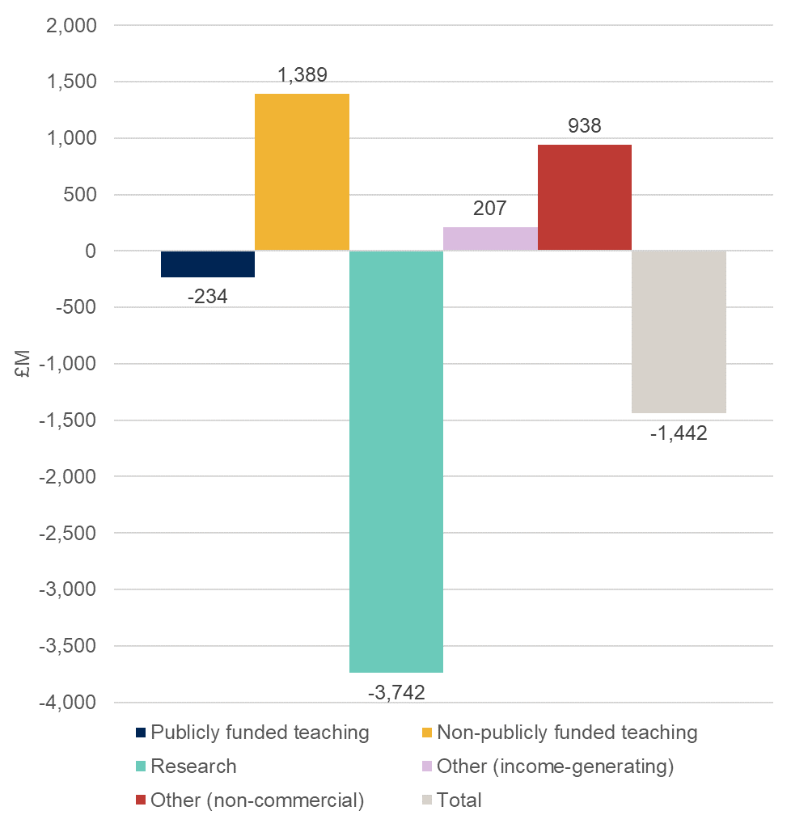

- Table 2 provides further analysis of research income and costs, analysed by research sponsor type. This shows that:
  - Research council funded research activity accounts for 19.8 per cent of total research costs with a recovery of 71.7 per cent of full economic cost, compared with 71.9 per cent in 2016-17.
  - Cost recovery on ‘Training and supervision of postgraduate research students’ continues to show the lowest recovery across the externally sponsored research activity, at 47.0 per cent. Postgraduate full-time equivalent student numbers, as reported in TRAC, decreased by 2.0 per cent from 81,535 to 79,925.
  - Quality-related research funding from Research England or Department for the Economy (Northern Ireland), available to support all ‘public good’ research, totalled £1,646 million.
  - Recovery of costs from ‘other government departments’ was 77.6 per cent, representing a decline in recovery from the 77.9 per cent cost recovery for 2016-17. Cost recovery from UK charities reduced from 60.8 per cent to 60.4 per cent whilst cost recovery on ‘Industry-sponsored’ research activity (including research funded by overseas government bodies and overseas charities) reduced from 78.1 per cent to 77.7 per cent.
- In line with previous years the sector continues to have a substantial level of activity that does not recover its full costs.
- UK sector aggregate data is provided in Tables 4, 5 and 6 at Annex B.
- Further analysis for the UK sector summarised by peer group is provided as an Excel workbook (see Annex C).

Contact
- For enquiries regarding the TRAC data please contact Heather Williams, Principal Analyst (Costing), email trac@officeforstudents.org.uk.

Table 2: Research income and costs by sponsor type, 2017-18 (higher education institutions in England and Northern Ireland) (figures in £M)
 | Recurrent research funding from Research England/ Department for the Economy | Institution own-funded | Training and supervision of postgraduate research students | Research councils | Other government departments | EU | UK charities | Industry | Total research
Income | 1,646 | 385 | 1,051 | 1,738 | 940 | 643 | 1,078 | 1,016 | 8,497
TRAC full economic costs |  | 2,286 | 2,235 | 2,424 | 1,212 | 988 | 1,785 | 1,308 | 12,239
Surplus/(deficit) |  | (1,901) | (1,184) | (686) | (272) | (345) | (707) | (292) | (3,742)
Surplus/(deficit) as % of income |  | (494.0)% | (112.7)% | (39.5)% | (28.9)% | (53.7)% | (65.6)% | (28.7)% | (44.0)%
Recovery of full economic costs % |  | 16.8% | 47.0% | 71.7% | 77.6% | 65.1% | 60.4% | 77.7% | 69.4%
Recovery of full economic costs % (2016-17) |  | 17.0% | 49.8% | 71.9% | 77.9% | 65.4% | 60.8% | 78.1% | 70.8%
Included in income
New endowments received | 34 | 33 | 5 | 0 | 0 | 0 | 0 | 6 | 78
New donations | 16 | 49 | 12 | 2 | 1 | 0 | 11 | 42 | 133
New government capital grants | 6 | 57 | 12 | 63 | 38 | 14 | 7 | 9 | 206
New non-government capital grants | 0 | 10 | 4 | 7 | 2 | 2 | 11 | 23 | 59
Other material items | 0 | 0 | 0 | 0 | 0 | 0 | 0 | 0 | 1
Total income items | 56 | 148 | 33 | 73 | 41 | 16 | 30 | 79 | 476
Total as % of income | 3.4% | 38.5% | 3.1% | 4.2% | 4.4% | 2.5% | 2.8% | 7.8% | 5.6%
Total as % of income (2016-17) | 0.1% | 58.2% | 3.7% | 5.8% | 4.3% | 1.7% | 3.5% | 8.8% | 6.3%

Notes to Table 2
‘European Union’ covers EU government bodies including the Commission. ‘Industry’ includes all other organisations such as UK industry, commerce and public corporations, EU non-government organisations (comprising EU-based charities, EU industry and any other EU source), overseas charities, overseas industry and other sources.

Annex A: Derivations

Table 3: Derivation of Transparent Approach to Costing (TRAC) full economic costs and TRAC surplus/(deficit) for higher education institutions in England and Northern Ireland
 | Total (£M)
Total income (derived from financial statements for 2017-18) | 33,646
Total expenditure (derived from financial statements for 2017-18) | 31,958
Operating surplus/(deficit) per audited financial statements | 1,688
Sustainability adjustment (EBITDA for MSI) | 3,130
Full economic cost (total expenditure plus the sustainability adjustment) | 35,088
TRAC surplus/(deficit) | (1,442)

Notes to Table 3
- The income and expenditure lines as reported in the financial statements are adjusted, where appropriate, in respect of pension costs, gains or losses on disposal of fixed assets, gains or losses on investments, share of surpluses or deficits in joint ventures and associates, taxation charges or credits and non-controlling interests, in line with the TRAC guidance for 2017-18 – Version 2.3.1 (October 2018) and Annual TRAC return template at Annex 4.1a.
- The sustainability adjustment is defined as ‘earnings before interest, tax, depreciation and amortisation’ (EBITDA) adjusted as defined in the TRAC guidance requirements (section 3.2.4 and template at Annex 3.2a) to provide the ‘margin for sustainability and investment’ (‘EBITDA for MSI’).
- Full economic cost is total expenditure derived from the financial statements, plus the sustainability adjustment.
- TRAC surplus/(deficit) is the difference between total income and the full economic costs.

Annex B: UK sector data summary

Table 4: Transparent Approach to Costing (TRAC) income and full economic costs by activity, 2017-18 (UK higher education institutions) (figures in £M)
 | Publicly funded teaching | Non-publicly funded teaching | Research | Other (income- generating) | Other  (non-commercial) | Total
Income | 15,065 | 5,717 | 10,026 | 6,516 | 1,428 | 38,753
TRAC full economic costs | 15,418 | 4,091 | 14,300 | 6,291 | 383 | 40,483
Surplus/(deficit) | (353) | 1,627 | (4,273) | 225 | 1,045 | (1,730)
Surplus/(deficit) as % of income | (2.3)% | 28.4% | (42.6)% | 3.5% | 73.2% | (4.5)%
Recovery of full economic costs % | 97.7% | 139.8% | 70.1% | 103.6% | 372.8% | 95.7%
Recovery of full economic costs % (2016-17) | 99.3% | 137.1% | 71.7% | 101.9% | 673.6% | 96.9%
Included in income
New endowments received | 7 | 39 | 76 | 5 | 35 | 162
New donations | 14 | 55 | 136 | 24 | 116 | 343
New government capital grants | 89 | 11 | 240 | 41 | 11 | 391
New non-government capital grants | 27 | 9 | 84 | 15 | 7 | 141
Other material items | 2 | 1 | 1 | 2 | 22 | 27
Total income items | 137 | 114 | 537 | 86 | 190 | 1,065
Total as % of income | 0.9% | 2.0% | 5.4% | 1.3% | 13.3% | 2.7%
Total as % income (2016-17) | 1.2% | 2.0% | 6.2% | 1.2% | 10.4% | 3.0%

Figure 2: TRAC full economic cost surplus/deficit by activity, 2017-18 (UK higher education institutions)
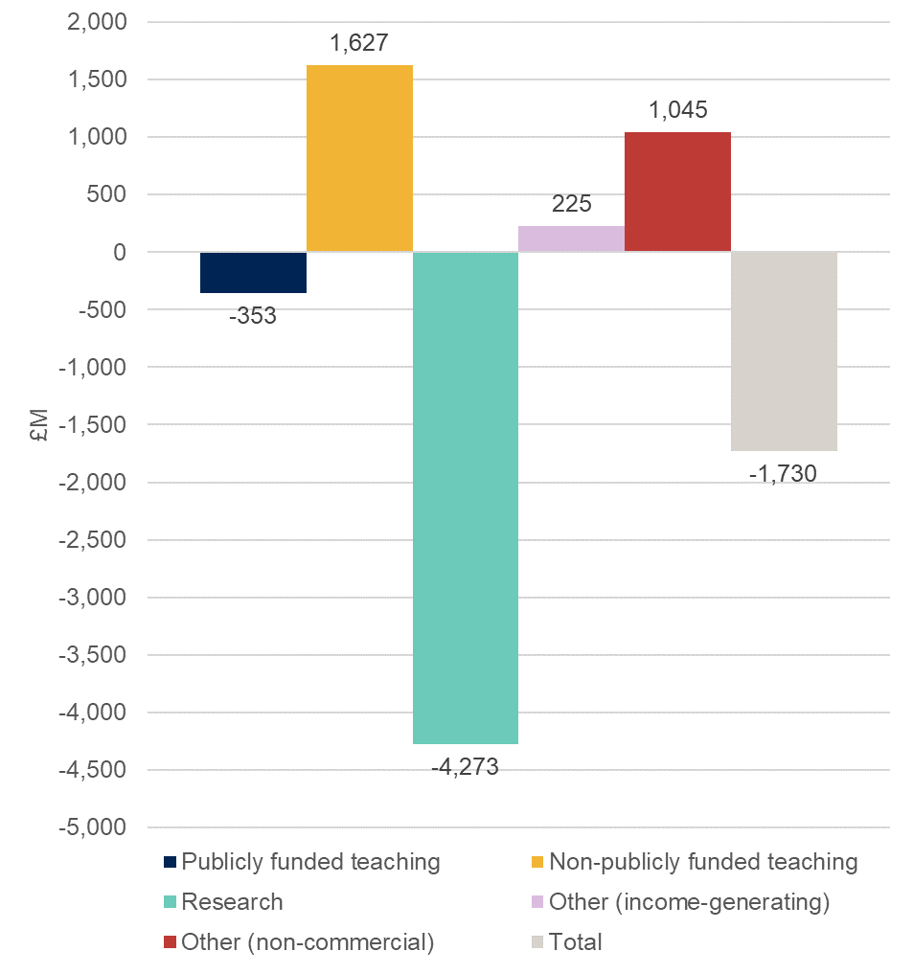

Definitions for Table 4 and Figure 2
Publicly funded teaching: Teaching of higher and further education courses to home and EU students who were fundable by HEFCE or the Department for the Economy (Northern Ireland) or by the NHS, National College of Teaching and Leadership, or Education and Skills Funding Agency. Income includes student fees paid via the Student Loans Company.
Non-publicly funded teaching: Teaching of students from outside the UK and EU; self-funded home and EU students and other commissioned courses (such as employer-specific ‘closed’ courses).
Research: All research activity (but not scholarship or staff development) commissioned and funded by external sponsors, or the institution’s own-funded research activity. Public sponsors of research include UK research councils and other government departments. Other sponsors include UK charities, the EU, overseas governments, overseas charities and research carried out for commercial or industrial sponsors.
Other (income-generating): Includes commercial activities such as catering and conferences, commercially let facilities and residences; activities carried out through subsidiary companies such as publishing or commercial consultancy; knowledge transfer activity; and, for institutions with medical and dental schools, services provided to the NHS.
Other (non-commercial): Non-commercial activity such as investment and donations or endowments.

Table 5: Research income and costs by sponsor type, 2017-18 (UK higher education institutions) (figures in £M)
 | Recurrent research funding from UK HE funding bodies / Research England | Institution own-funded | Training and supervision of postgraduate research students | Research councils | Other government departments | EU | UK charities | Industry | Total research
Income | 1,963 | 439 | 1,214 | 2,078 | 1,121 | 775 | 1,273 | 1,165 | 10,026
TRAC full economic costs |  | 2,560 | 2,600 | 2,887 | 1,452 | 1,183 | 2,102 | 1,516 | 14,300
Surplus/(deficit) |  | (2,121) | (1,386) | (809) | (332) | (408) | (829) | (351) | (4,273)
Surplus/(deficit) as % of income |  | (483.6)% | (114.2)% | (38.9)% | (29.6)% | (52.7)% | (65.1)% | (30.2)% | (42.6)%
Recovery of full economic costs % |  | 17.1% | 46.7% | 72.0% | 77.2% | 65.5% | 60.6% | 76.8% | 70.1%
Recovery of full economic costs % (2016-17) |  | 17.3% | 49.4% | 72.4% | 78.4% | 65.9% | 61.2% | 77.0% | 71.7%
Included in income
New endowments received | 34 | 33 | 5 | 0 | 0 | 0 | 0 | 6 | 78
New donations | 16 | 49 | 13 | 2 | 1 | 0 | 11 | 42 | 134
New government capital grants | 7 | 68 | 14 | 70 | 42 | 19 | 11 | 11 | 241
New non-government capital grants | 0 | 16 | 5 | 17 | 3 | 4 | 14 | 25 | 84
Other material items | 0 | 0 | 0 | 0 | 0 | 0 | 0 | 0 | 1
Total income items | 56 | 166 | 37 | 88 | 46 | 23 | 37 | 84 | 537
Total as % of income | 2.9% | 37.8% | 3.1% | 4.2% | 4.1% | 3.0% | 2.9% | 7.2% | 5.4%
Total as % income (2016-17) | 0.1% | 55.2% | 3.6% | 5.8% | 4.8% | 2.0% | 3.6% | 8.8% | 6.2%

Notes to Table 5
‘European Union’ covers EU government bodies including the Commission. ‘Industry’ includes all other organisations such as UK industry, commerce and public corporations, EU non-government organisations (comprising EU-based charities, EU industry and any other EU source), overseas charities, overseas industry and other sources.

Table 6: Derivation of Transparent Approach to Costing (TRAC) full economic costs and TRAC surplus/(deficit) (UK higher education institutions)
 | Total (£M)
Total income (derived from financial statements for 2017-18) | 38,753
Total expenditure (derived from financial statements for 2017-18) | 37,005
Operating surplus/(deficit) per audited financial statements | 1,748
Sustainability adjustment (EBITDA for MSI) | 3,478
Full economic cost (total expenditure plus the sustainability adjustment) | 40,483
TRAC surplus/(deficit) | (1,730)

Notes to Table 6
- The income and expenditure lines as reported in the financial statements are adjusted, where appropriate, in respect of pension costs, gains or losses on disposal of fixed assets, gains or losses on investments, share of surpluses or deficits in joint ventures and associates, taxation charges or credits and non-controlling interests, in line with the TRAC guidance for 2017-18 – Version 2.3.1 (October 2018) and Annual TRAC return template (Annex 4.1a).
- The sustainability adjustment is defined as ‘earnings before interest, tax, depreciation and amortisation’ (EBITDA) adjusted as defined in the TRAC guidance requirements (section 3.2.4 and template at Annex 3.2a) to provide the ‘margin for sustainability and investment’ (‘EBITDA for MSI’).
- Full economic cost is total expenditure derived from the financial statements, plus the sustainability adjustment.
- TRAC surplus/(deficit) is the difference between total income and the full economic costs.

Annex C: UK peer group summary 2017-18
- Sector peer group summary is provided as an Excel file. The Excel workbook contains three worksheets:
- Tables 1 and 2 provide analysis of TRAC full economic costs and cost recovery on the main activities, analysed by TRAC peer group
- Table 3 provides recovery of full economic costs for research, by research sponsor type, analysed by TRAC peer group
- Table 4 provides analysis of the sustainability adjustment and TRAC surplus/(deficit).

Analysis by TRAC peer group: methodology
- The worksheets provide summary data (average, median and quartiles) for the UK sector and each of the TRAC peer groups (groups A to F), including charts.
- Higher education institutions have been allocated to TRAC peer groups based on levels of research income, having a medical school, overall total income or specialism in music or the arts.
- 51 higher education institutions apply dispensation on TRAC, meaning that they are not required to comply fully with all of the requirements of TRAC. These institutions have been excluded from the peer group analysis.
- When considering the analysis in the report, the number of institutions with data in each peer group should be taken into consideration; these are shown at the top of each table.
- After exclusion of higher education institutions that apply dispensation, peer group F contains only three institutions. This is below our publication threshold, and therefore no data is shown for peer group F.
- In all tables, the words ‘UK sector’ are used to refer to all UK higher education institutions across all peer groups (except those applying dispensation).

© The Office for Students copyright 2019
This publication is available under the Open Government Licence 3.0 except where it indicates that the copyright for images or text is owned elsewhere.
www.nationalarchives.gov.uk/doc/open-government-licence/version/3/w

For the purposes of this publication, higher education institutions are those institutions that were previously funded by the Higher Education Funding Council for England (HEFCE) and were required to submit annual TRAC returns for 2017-18; and higher education institutions funded by the Scottish Funding Council, Higher Education Funding Council for Wales and the Department for the Economy (Northern Ireland).
The analysis is based on 132 higher education institutions that were previously funded by HEFCE in 2017-18 and are now funded by the Office for Students, and two higher education institutions funded by the Department for the Economy, Northern Ireland.
Available at: www.officeforstudents.org.uk/data-and-analysis/trac-data/published-data-2017-18/.
TRAC full economic costs comprise the total expenditure from audited financial statements plus the sustainability adjustment: the margin for sustainability and investment (MSI).
This figure includes net Research and Development Expenditure Credit (RDEC) income, as the total value of claims received in 2016-17 and 2017-18 is not material. In previous years some institutions were able to benefit from the RDEC scheme established by the government in 2013 to offer tax incentives to large companies to encourage greater investment in research and development, until the rules of the scheme were amended. Institutions that made claims for eligible expenditure, in the periods 2012-13 to 2014-15, received payment which represented a large one-off financial benefit, with most institutions receiving the payments in the periods 2013-14 to 2015-16. As the value of RDEC was material in these earlier years, prior TRAC publications presented figures excluding RDEC.
2016-17 data has been updated to reflect amended data for one institution, and therefore may differ slightly from figures published in ‘Annual TRAC 2016-17’.
Definitions for this table can be found on page 5. Figures in this and subsequent tables may not sum because of rounding.
Data does not include postgraduate students at institutions that apply dispensation from the TRAC requirements.
10 The TRAC guidance is available at www.trac.ac.uk/tracguidance/.
1² The TRAC guidance is available at www.trac.ac.uk/tracguidance/.
Available at www.officeforstudents.org.uk/data-and-analysis/trac-data/published-data-2017-18/.
A list of higher education institutions and the criteria used in defining each peer group can be found at Annex 4.1b of the TRAC guidance, available at: www.trac.ac.uk/tracguidance/.
For further information about dispensation see Annex 1.2b of the TRAC guidance, available at: www.trac.ac.uk/tracguidance/.

