Annual TRAC 2019-20
Sector summary and analysis by
TRAC peer group

Reference OfS 2021.31
Enquiries to trac@officeforstudents.org.uk
Publication date 29 July 2021

Contents
Background 2
Contact 3
Key points 4
Definitions for Table 1 and Figure 1 6
Table 1: TRAC income and full economic costs by activity, 2019-20 (higher education institutions in England and Northern Ireland) (figures in £M) 7
Figure 1: TRAC full economic cost surplus/deficit by activity, 2019-20 (higher education institutions in England and Northern Ireland) 8
Table 2: Research income and costs by sponsor type, 2019-20 (higher education institutions in England and Northern Ireland) (figures in £M) 10
Annex A: Derivation 12
Table 3: Derivation of Transparent Approach to Costing (TRAC) full economic costs and TRAC surplus/(deficit), 2019-20 (higher education institutions in England and Northern Ireland) 12
Annex B: UK sector data summary 13
Table 4: TRAC income and full economic costs by activity, 2019-20 (UK higher education institutions) (figures in £M) 13
Figure 2: TRAC full economic cost surplus/deficit by activity, 2019-20 (UK higher education institutions) 14
Definitions for Table 4 and Figure 2 15
Table 5: Research income and costs by sponsor type, 2019-20 (UK higher education institutions) (figures in £M) 16
Table 6: Derivation of Transparent Approach to Costing (TRAC) full economic costs and TRAC surplus/(deficit), 2019-20 (UK higher education institutions) 18
Annex C: UK peer group summary 2019-20 19
Analysis by TRAC peer group: methodology 19

Background
- All UK higher education institutions are required to report Transparent Approach to Costing (TRAC) data annually by 31 January each year. Further education colleges and other providers of higher education are not currently required to submit TRAC data. TRAC data was first collected for academic year 1999-2000. TRAC data for 2019-20 was collected by the Office for Students (OfS) on behalf of UK Research and Innovation, the Scottish Funding Council, the Higher Education Funding Council for Wales and the Department for the Economy (Northern Ireland) and these bodies are co-owners of the data.
- For 2019-20 TRAC reporting, providers were granted flexibility to submit the annual TRAC return on a later timescale if necessary, due to the impact of the COVID-19 pandemic on the operating environment for all providers and the impact on the timing for submission of audited financial statements and the Annual Financial Return for providers in England, and the HESA Finance Return for institutions in Northern Ireland, Scotland and Wales. The deadline for all providers to submit and sign off the TRAC return by the Accountable Officer was 31 March 2021. The majority of providers were able to submit and sign off the TRAC return by this deadline, but some required extensions beyond this date to complete the process.,
- The TRAC guidance for 2019-20 reporting (version 2.5) included an additional annex (1.1b) covering COVID-19 supplementary TRAC guidance. This addressed adjustments required or permitted in relation to reporting of activities, costs and income for the period affected by the COVID-19 operational disruptions. In particular, it included guidance on the impact on the activities of academic staff during the period affected by the COVID-19 pandemic lockdown in the UK (March to July 2020), and definitions and approaches for estimating and reporting the impacts within the TRAC return for 2019-20.
- We intend to release – as an ad hoc experimental official statistic – a summary of some additional contextual information collected within the TRAC return for 2019-20. This is to aid the interpretation of the TRAC data for 2019-20 and to estimate the impact of the COVID-19 pandemic on the operations of higher education providers in the period from March to July 2020. The summary will look at the estimated impact on changes to academic staff activities and estimated impact on the academic staff costs included in the TRAC full economic costs reported for 2019-20. We intend to publish this shortly.
- 2019-20 is the fourth year in which TRAC reporting has been prepared under the new Higher Education Statement of Recommended Practice, applying Financial Reporting Standard (FRS) 102. This reporting standard introduced some significant changes in the way financial performance is reported, making comparison difficult between the latest results and historical TRAC data prior to 2015-16, as well as resulting in potentially greater variability in income between years. The changes lead to earlier recognition of income from new donations, endowments (in full in the year of receipt) and new capital grants (often in full in the year of receipt, except where the accruals method is used for accounting for government capital grants), which may be ahead of the expenditure which they support. Further, in 2016-17, there was a change in the method for calculating the sustainability adjustment with the ‘Margin for sustainability and investment’ (MSI) replacing the previous method. Data for 2016-17 therefore formed the baseline for the start of a new time series of TRAC data. Analyses of the annual TRAC data for 2016-17, 2017-18 and 2018-19 are available on the OfS website.
- This paper contains analysis of the 2019-20 sector aggregate data based on submissions from 133 higher education institutions in England and Northern Ireland. Aggregated data for 160 UK higher education institutions is provided in Annex B. Data was collected from a further two providers in England, but has been excluded from this analysis.
- This paper also contains annual TRAC data for 2019-20 analysed by TRAC peer group (Annex C and Excel workbook).

Contact
For enquiries regarding the TRAC data, please contact Heather Williams, Principal Analyst (Costing), email trac@officeforstudents.org.uk.

Key points
- The annual TRAC return for 2019-20 shows a sector aggregate deficit of £2,833 million for higher education institutions in England and Northern Ireland, with 92.5 per cent of TRAC full economic costs recovered. This compares with a deficit of £1,427 million and a recovery of 96.1 per cent in 2018-19. This excess of costs over income is consistent with the previous year, but for 2019-20 the impact of the COVID-19 pandemic has been an additional factor affecting both income and costs, with total income showing a small reduction of £164 million to £35,142 million compared with an increase of 5.5 per cent in 2018-19. The full economic cost of all activities increased by £1,242 million to £37,975 million – an increase of 3.4 per cent.
- This change in full economic costs comprises:
- Staff cost decreases of £5,389 million (a decrease of 24.6 per cent) as reported in higher education providers’ Finance Return and audited financial statements. This decline was largely due to an exceptional, non-cash accounting expense of £4,116 million recorded in 2018-19 to reflect the increase to the deficit contributions that employers made to pension schemes, most substantially the Universities Superannuation Scheme (USS) following the finalisation of the 2017 USS valuation. When removing changes to pension provision to staff costs, as reported in the financial statements and OfS Annual Financial Return and HESA Finance Return (for institutions in Northern Ireland), the underlying increase in staff costs between 2018-19 to 2019-20 was 5.9 per cent. As this accounting adjustment is not reflective of annual operating costs, the TRAC methodology makes adjustment for the distortion caused by the impact of the accounting for the USS deficit recovery plan, replacing the financial accounting charges with the annual cash contributions (which include deficit contributions). In 2018-19 the net USS pension adjustment included in TRAC was a net deduction of £3,823 million. In 2019-20 the unwinding of USS pension provision and replacement with annual cash contributions resulted in a net USS pension adjustment addition of £2,605 million.
- Other operating cost decreases of £233 million (-1.9 per cent) and an increase in depreciation of £90 million (4.0 per cent).
- A small reduction in the sustainability adjustment of £87 million to £3,106 million, compared with a small increase of £92 million in 2018-19. The sustainability adjustment represents 8.2 per cent of full economic costs, compared with 8.7 per cent of full economic costs in 2018-19. The sustainability adjustment is calculated based on a six-year average of ‘earnings before interest, taxation, depreciation and amortisation’ (EBITDA) based on data for the latest three years’ audited financial statements and three years’ forecast performance. The reduction in the aggregate sustainability adjustment for 2019-20 for the sector reflects both the reduction in EBITDA (cash generation) incurred in 2019-20 and forecast reductions in one or more future years due to the impact of the COVID-19 on projections for future income and costs as well as other factors affecting institutions’ projections. It also reflects uncertainty in higher education institutions’ forecasts, as prepared and submitted in late 2020 or early 2021 and variability of the impacts across institutions (e.g. the timescale and duration of the impacts depending on individual providers’ circumstances, mitigations taken or planned), and judgements made by individual institutions in preparing financial forecasts.
- Changes in operating arrangements and impact on associated operating costs due to the COVID-19 pandemic and the national lockdown from March to July 2020. Higher education providers will have incurred a range of additional costs in order to support staff and students to continue on campus during the period prior to the national lockdown, or to work from home and continue delivering teaching, research and support services, as well as in supporting students to continue their studies. Against this, institutions may have taken a range of steps to reduce costs, for example of running the estates and on-campus facilities, or to defer planned expenditure.
- Total income includes £953 million of income from new endowments received, new donations and new capital grants and other material income, representing 2.7 per cent of income, a reduction on the £1,028 million (2.9 per cent) income from these sources in 2018-19. This has the effect of reducing the shortfall on cost recovery as income will be recognised in full on receipt, whereas the expenditure supported from these sources may be incurred in subsequent years.
- Table 1 and Figure 1 show the sector aggregate TRAC data by activity for higher education institutions in England and Northern Ireland. Key points are:
- Publicly funded teaching incurred a small deficit on a full economic cost basis – meaning that costs exceeded income, with 96.2 per cent of the full economic costs recovered compared with 96.7 per cent in 2018-19.
- Non-publicly funded teaching (primarily overseas students) continued to generate a significant surplus: £1,993 million recovering 147.4 per cent of costs, representing an increase in recovery from £1,666 million recovering 144.1 per cent of costs from 2018-19.
- Research continues to show a substantial deficit, increasing from £3,899 million in 2018-19 to £4,009 million. This represents a recovery of only 68.8 per cent of full economic costs – a small deterioration from the 2018-19 recovery of 69.6 per cent of full economic costs, but notably lower than in 2010-11 when the recovery rate on research peaked at 77.8 per cent. Research income for 2019-20 includes £405 million of income from new endowments and donations, and new capital grants, representing 4.6 per cent of research income. This compares with £567 million (6.3 per cent of research income) in 2018-19.
- Other (income-generating) activities show a deficit with costs exceeding income by £792 million, representing a recovery rate of only 86.9 per cent. This represents a significant change from the previous year which recorded a small surplus of income over costs of £213 million representing a recovery of 103.6 per cent. Total income reduced from £6,101 million to £5,270 million – largely attributable to the waiver, or refund, of accommodation fees made to students in institution-owned accommodation, as well as to the loss of revenue from on-campus catering, facilities and conference operations – whilst the full economic costs increased from £5,889 million to £6,063 million.
- Other (non-commercial) activity (income from investments, donations and endowments, and capital grants received in the year that are not allocated to teaching or research), off-set by expenditure funded from these sources in the year, shows a surplus of £520 million. This represents a significant reduction from £1,047 million in 2018-19. Some caution is required in interpreting this category as FRS102 causes potentially significant distortion: the reporting standard requires recognition of new endowments and donations and new capital grants received in year, as income in full in the year of receipt, while the funds will support expenditure arising in subsequent years (such as investment in buildings, equipment and facilities). In 2019-20, income from new endowments, donations, new capital grants and other material items totalled £281 million, representing 25.2 per cent of other (non-commercial) income, compared with 13.7 per cent in 2018-19.

Definitions for Table 1 (page 7) and Figure 1 (page 8)
Publicly funded teaching: Teaching of higher and further education courses to home and EU students who were fundable by the OfS or the Department for the Economy (Northern Ireland) or by the NHS, National College of Teaching and Leadership, or Education and Skills Funding Agency. Income includes student fees paid via the Student Loans Company.
Non-publicly funded teaching: Teaching of students from outside the UK and EU; self-funded home and EU students and other commissioned courses (such as employer-specific ‘closed’ courses).
Research: All research activity (but not scholarship or staff development) commissioned and funded by external sponsors, or the institution’s own-funded research activity. Public sponsors of research include UK research councils and other government departments. Other sponsors include UK charities, the EU, overseas governments, overseas charities and research carried out for commercial or industrial sponsors.
Other (income-generating): Includes commercial activities such as catering and conferences, commercially let facilities and residences; activities carried out through subsidiary companies such as publishing or commercial consultancy; knowledge transfer activity; and, for institutions with medical and dental schools, services provided to the NHS.
Other (non-commercial): Non-commercial activity such as investment and donations or endowments.

Table 1: TRAC income and full economic costs by activity, 2019-20 (higher education institutions in England and Northern Ireland) (figures in £M)
 | Teaching | Teaching | Research | Other | Other | Total
 | (Publicly funded) | (Non-publicly funded) |  | (Income- generating) | (Non-commercial)
TRAC income | 13,707 | 6,195 | 8,857 | 5,270 | 1,113 | 35,142
TRAC full economic costs | 14,251 | 4,202 | 12,866 | 6,063 | 592 | 37,975
TRAC surplus/(deficit) | (544) | 1,993 | (4,009) | (792) | 520 | (2,833)
TRAC surplus/(deficit) as % of income | (4.0%) | 32.2% | (45.3%) | (15.0%) | 46.8% | (8.1%)
Recovery of full economic costs % | 96.2% | 147.4% | 68.8% | 86.9% | 187.9% | 92.5%
Recovery of full economic costs % (2018-19) | 96.7% | 144.1% | 69.6% | 103.6% | 355.7% | 96.1%
Included in income
New endowments received | 19 | 61 | 83 | 4 | 122 | 290
New donations | 14 | 33 | 80 | 9 | 122 | 257
New government capital grants | 53 | 8 | 212 | 28 | 8 | 310
New non-government capital grants | 11 | 5 | 28 | 14 | 27 | 86
Other material items | 4 | (2) | 2 | 6 | 2 | 12
Total income items | 101 | 106 | 405 | 62 | 281 | 953
Total as % of income | 0.7% | 1.7% | 4.6% | 1.2% | 25.2% | 2.7%
Total as % of income (2018-19) | 0.8% | 1.7% | 6.3% | 1.0% | 13.7% | 2.9%

Figure 1: TRAC full economic cost surplus/deficit by activity, 2019-20 (higher education institutions in England and Northern Ireland)
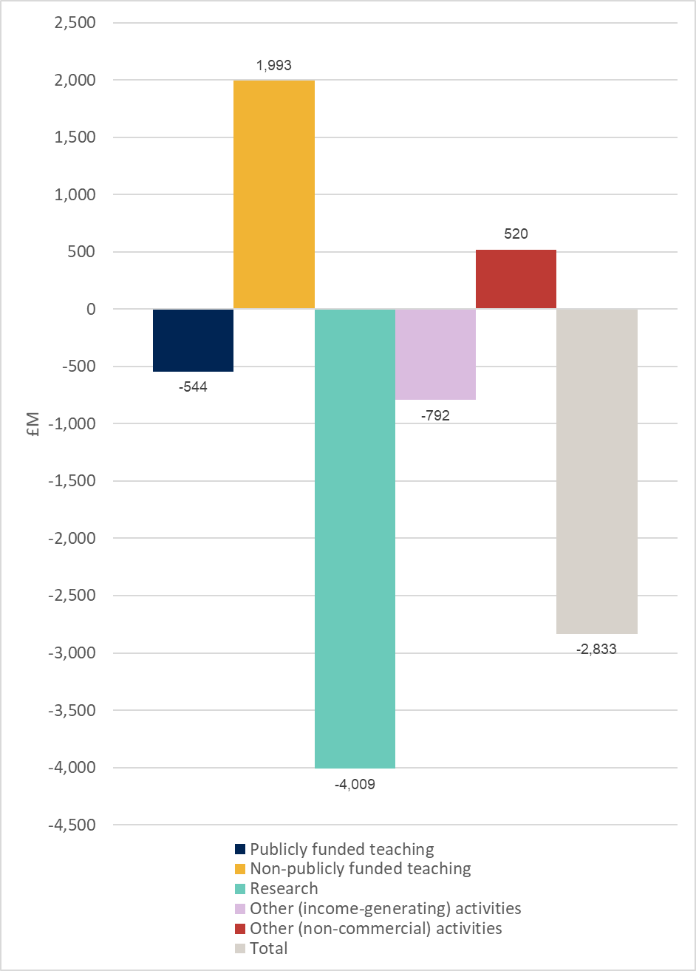

- Table 2 provides further analysis of research income and costs, analysed by research sponsor type. This shows that:
- Research council funded research activity accounted for 20.0 per cent of total research costs, with a recovery of 70.9 per cent of full economic cost, compared with 73.7 per cent in 2018-19.
- Cost recovery on ‘Training and supervision of postgraduate research students’ continues to show the lowest recovery across the externally sponsored research activity, at 45.9 per cent. Postgraduate full-time equivalent student numbers, as reported in TRAC, reduced by 0.8 per cent from 81,209 in 2018-19 to 80,591.
- Quality-related research funding from Research England (RE) or Department for the Economy (Northern Ireland) (DfENI), available to support all ‘public good’ research, totalled £1,840 million.
- Recovery of costs from ‘other government departments’ was 73.7 per cent, representing a reduction in recovery from the 74.5 per cent cost recovery for 2018-19. Cost recovery from UK charities reduced from 58.7 per cent to 57.4 per cent, while cost recovery on ‘Industry-sponsored’ research activity (including research funded by overseas government bodies and overseas charities) reduced from 77.6 per cent to 76.1 per cent.
- In line with previous years, the sector continues to have a substantial level of activity that does not recover its full costs. In the latter part of the 2019-20 academic year, the impact of the COVID-19 pandemic on higher education institutions’ operations impacted most significantly on Other (income-generating) activities, with significant losses in income from student accommodation, catering and on-campus facilities, and conferences. The data for 2019-20 should be interpreted taking account of the impact of the COVID-19 pandemic across all activities. The additional information to be released shortly as an ad hoc experimental official statistic should be used to provide context in interpreting the 2019-20 data.
- UK sector aggregate data is provided in Tables 4, 5 and 6 at Annex B.
- Further analysis for the UK sector summarised by peer group is provided as an Excel workbook (see Annex C).

Table 2: Research income and costs by sponsor type, 2019-20 (higher education institutions in England and Northern Ireland) (figures in £M)
 | Recurrent research funding from the Funding Councils | Institution own-funded | Training and supervision of postgraduate research students | Research Councils | Other government departments | EU | UK charities | Industry | Total research
TRAC income | 1,840 | 406 | 1,087 | 1,825 | 950 | 588 | 1,059 | 1,101 | 8,857
TRAC full economic costs |  | 2,392 | 2,368 | 2,575 | 1,289 | 948 | 1,847 | 1,447 | 12,866
TRAC surplus/(deficit) |  | (1,986) | (1,281) | (750) | (339) | (360) | (787) | (346) | (4,009)
TRAC surplus/(deficit) as % of income |  | (489.8%) | (117.8%) | (41.1%) | (35.7%) | (61.1%) | (74.3%) | (31.5%) | (45.3%)
Recovery of full economic costs % |  | 17.0% | 45.9% | 70.9% | 73.7% | 62.1% | 57.4% | 76.1% | 68.8%
Recovery of full economic costs % (2018-19) |  | 21.2% | 45.2% | 73.7% | 74.5% | 65.3% | 58.7% | 77.6% | 69.6%
Included in income
New endowments received | 0 | 78 | 2 | 0 | 0 | 0 | 0 | 4 | 84
New donations | 0 | 40 | 9 | 2 | 1 | 0 | 3 | 24 | 79
New government capital grants | 3 | 68 | 11 | 71 | 29 | 8 | 12 | 9 | 212
New non-government capital grants | 0 | 2 | 1 | 8 | 2 | 2 | 9 | 4 | 28
Other material items | 0 | 2 | 0 | 0 | 0 | 0 | 0 | 0 | 2
Total income items | 3 | 191 | 23 | 80 | 33 | 9 | 25 | 41 | 405
Total as % of income | 0.2% | 47.0% | 2.1% | 4.4% | 3.5% | 1.6% | 2.4% | 3.7% | 4.6%
Total as % of income (2018-19) | 0.5% | 46.3% | 11.6% | 3.2% | 2.6% | 2.4% | 2.7% | 6.8% | 6.3%

Notes to Table 2
- ‘European Union’ covers EU government bodies including the Commission.
- ‘Industry’ includes all other organisations such as UK industry, commerce and public corporations, EU non-government organisations (comprising EU-based charities, EU industry and any other EU source), overseas charities, overseas industry and other sources.

Annex A: Derivation

Table 3: Derivation of Transparent Approach to Costing (TRAC) full economic costs and TRAC surplus/(deficit), 2019-20 (higher education institutions in England and Northern Ireland)
 | Total (£M)
Total income adjusted for TRAC (derived from financial statements for 2019-20) | 35,142
Total expenditure adjusted for TRAC (derived from financial statements for 2019-20) | 34,869
Operating surplus/(deficit) per audited financial statements | 273
Sustainability adjustment (EBITDA for MSI) | 3,106
Full economic cost (total expenditure plus target surplus for sustainable operations) | 37,975
TRAC surplus/(deficit) | (2,833)

Notes to Table 3
- The income and expenditure lines as reported in the financial statements are adjusted, where appropriate, in respect of pension costs, gains or losses on disposal of fixed assets, gains or losses on investments, share of surpluses or deficits in joint ventures and associates, taxation charges or credits and non-controlling interests, in line with the TRAC guidance for 2019-20 – Version 2.5 (July 2020) and Annual TRAC return template at Annex 4.1a.
- The sustainability adjustment is defined as ‘earnings before interest, tax, depreciation and amortisation’ (EBITDA), adjusted as defined in the TRAC guidance requirements (section 3.2.4 and template at Annex 3.2a) to provide the ‘margin for sustainability and investment’ (‘EBITDA for MSI’).
- Full economic cost is total expenditure derived from the financial statements, plus the sustainability adjustment.
- TRAC surplus/(deficit) is the difference between total income and the full economic costs.

Annex B: UK sector data summary

Table 4: TRAC income and full economic costs by activity, 2019-20 (UK higher education institutions) (figures in £M)
 | Teaching | Teaching | Research | Other | Other | Total
 | (Publicly funded) | (Non-publicly funded) |  | (Income- generating) | (Non-commercial)
TRAC income | 15,872 | 7,244 | 10,531 | 6,026 | 1,226 | 40,899
TRAC full economic costs | 16,569 | 4,918 | 15,105 | 6,824 | 656 | 44,072
TRAC surplus/(deficit) | (696) | 2,326 | (4,575) | (798) | 570 | (3,172)
TRAC surplus/(deficit) as % of income | (4.4%) | 32.1% | (43.4%) | (13.2%) | 46.5% | (7.8%)
Recovery of full economic costs % | 95.8% | 147.3% | 69.7% | 88.3% | 187.0% | 92.8%
Recovery of full economic costs % (2018-19) | 96.2% | 144.2% | 70.8% | 104.3% | 348.0% | 96.1%
Included in income
New endowments received | 21 | 82 | 85 | 5 | 125 | 318
New donations | 17 | 35 | 81 | 10 | 160 | 303
New government capital grants | 75 | 17 | 273 | 31 | 28 | 423
New non-government capital grants | 16 | 7 | 46 | 17 | 27 | 113
Other material items | 4 | (2) | 2 | 6 | 19 | 29
Total income items | 133 | 138 | 486 | 69 | 359 | 1,185
Total as % of income | 0.8% | 1.9% | 4.6% | 1.1% | 29.3% | 2.9%
Total as % of income (2018-19) | 1.0% | 1.9% | 6.5% | 1.0% | 16.1% | 3.1%

Figure 2: TRAC full economic cost surplus/deficit by activity, 2019-20 (UK higher education institutions)
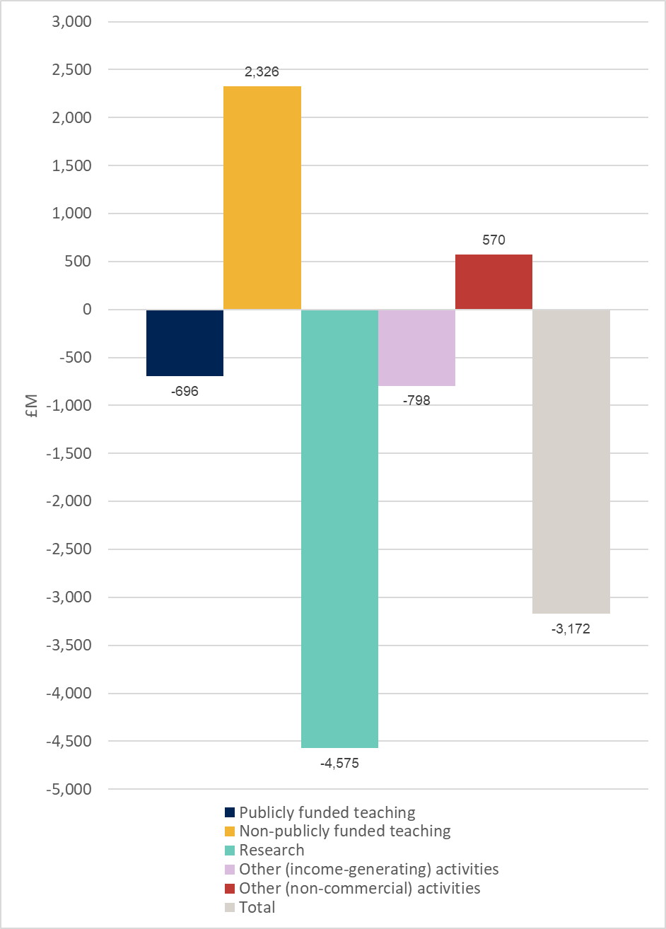

Definitions for Table 4 and Figure 2
Publicly funded teaching: Teaching of higher and further education courses to home and EU students who were fundable by the OfS, Scottish Funding Council, Higher Education Funding Council for Wales or the Department for the Economy (Northern Ireland) or by the NHS, National College of Teaching and Leadership, or Education and Skills Funding Agency. Income includes student fees paid via the Student Loans Company.
Non-publicly funded teaching: Teaching of students from outside the UK and EU; self-funded home and EU students and other commissioned courses (such as employer-specific ‘closed’ courses).
Research: All research activity (but not scholarship or staff development) commissioned and funded by external sponsors, or the institution’s own-funded research activity. Public sponsors of research include UK research councils and other government departments. Other sponsors include UK charities, the EU, overseas governments, overseas charities and research carried out for commercial or industrial sponsors.
Other (income-generating): Includes commercial activities such as catering and conferences, commercially let facilities and residences; activities carried out through subsidiary companies such as publishing or commercial consultancy; knowledge transfer activity; and, for institutions with medical and dental schools, services provided to the NHS.
Other (non-commercial): Non-commercial activity such as investment and donations or endowments.

Table 5: Research income and costs by sponsor type, 2019-20 (UK higher education institutions) (figures in £M)
 | Recurrent research funding from the Funding Councils | Institution own-funded | Training and supervision of postgraduate research students | Research Councils | Other government departments | EU | UK charities | Industry | Total research
TRAC income | 2,196 | 462 | 1,271 | 2,176 | 1,182 | 731 | 1,246 | 1,266 | 10,531
TRAC full economic costs |  | 2,688 | 2,788 | 3,051 | 1,559 | 1,164 | 2,172 | 1,684 | 15,105
TRAC surplus/(deficit) |  | (2,226) | (1,517) | (875) | (377) | (433) | (926) | (418) | (4,575)
TRAC surplus/(deficit) as % of income |  | (481.5%) | (119.3%) | (40.2%) | (31.9%) | (59.2%) | (74.3%) | (33.0%) | (43.4%)
Recovery of full economic costs % |  | 17.2% | 45.6% | 71.3% | 75.8% | 62.8% | 57.4% | 75.2% | 69.7%
Recovery of full economic costs % (2018-19) |  | 21.0% | 45.3% | 74.1% | 74.9% | 68.9% | 59.5% | 77.2% | 70.8%
Included in income
New endowments received | 0 | 78 | 2 | 1 | 0 | 0 | 1 | 4 | 85
New donations | 0 | 41 | 9 | 2 | 1 | 0 | 3 | 24 | 80
New government capital grants | 5 | 82 | 16 | 82 | 40 | 11 | 21 | 14 | 273
New non-government capital grants | 0 | 3 | 3 | 16 | 3 | 3 | 12 | 6 | 46
Other material items | 0 | 2 | 0 | 0 | 0 | 0 | 0 | 0 | 2
Total income items | 5 | 206 | 30 | 100 | 45 | 15 | 36 | 48 | 486
Total as % of income | 0.2% | 44.6% | 2.4% | 4.6% | 3.8% | 2.0% | 2.9% | 3.8% | 4.6%
Total as % of income (2018-19) | 0.4% | 44.1% | 10.6% | 4.1% | 2.7% | 7.0% | 3.4% | 6.6% | 6.5%

Notes to Table 5
- ‘European Union’ covers EU government bodies including the Commission.
- ‘Industry’ includes all other organisations such as UK industry, commerce and public corporations, EU non-government organisations (comprising EU-based charities, EU industry and any other EU source), overseas charities, overseas industry and other sources.

Table 6: Derivation of Transparent Approach to Costing (TRAC) full economic costs and TRAC surplus/(deficit), 2019-20 (UK higher education institutions)
 | Total (£M)
Total income adjusted for TRAC (derived from financial statements for 2019-20) | 40,899
Total expenditure adjusted for TRAC (derived from financial statements for 2019-20) | 40,615
Operating surplus/(deficit) per audited financial statements | 284
Sustainability adjustment (EBITDA for MSI) | 3,457
Full economic cost (total expenditure plus target surplus for sustainable operations) | 44,072
TRAC surplus/(deficit) | (3,172)

Notes to Table 6
- The income and expenditure lines as reported in the financial statements are adjusted, where appropriate, in respect of pension costs, gains or losses on disposal of fixed assets, gains or losses on investments, share of surpluses or deficits in joint ventures and associates, taxation charges or credits and non-controlling interests, in line with the TRAC guidance for 2019-20 – Version 2.5 (July 2020) and Annual TRAC return template at Annex 4.1a.
- The sustainability adjustment is defined as ‘earnings before interest, tax, depreciation and amortisation’ (EBITDA), adjusted as defined in the TRAC guidance requirements (section 3.2.4 and template at Annex 3.2a) to provide the ‘margin for sustainability and investment’ (‘EBITDA for MSI’).
- Full economic cost is total expenditure derived from the financial statements, plus the sustainability adjustment.
- TRAC surplus/(deficit) is the difference between total income and the full economic costs.

Annex C: UK peer group summary 2019-20
- The sector peer group summary is provided as an Excel file. The Excel workbook contains three worksheets of data:
- Tables 1 and 2 provide analysis of TRAC full economic costs and cost recovery on the main activities, analysed by TRAC peer group
- Table 3 provides recovery of full economic costs for research, by research sponsor type, analysed by TRAC peer group
- Table 4 provides analysis of the sustainability adjustment and TRAC surplus/(deficit).

Analysis by TRAC peer group: methodology
- The worksheets provide summary data (averages, medians and quartiles) for the UK sector and each of the TRAC peer groups (groups A to F), including charts.
- Higher education institutions have been allocated to TRAC peer groups based on levels of research income, overall total income, having a medical school, or specialism in music or the arts. TRAC peer groups are set for a number of years in order to maintain a stable group for comparison, and so are not updated annually. The review and updating of peer groups, which was planned for reporting on 2019-20 data, has been deferred pending the outcome of the Review of TRAC.
- When considering the analysis in the peer group tables, the number of institutions with data in each peer group should be taken into consideration; these are shown at the top of each table.
- In all tables, the ‘UK sector’ has been split into three categories: All institutions; those not applying dispensation; and those applying dispensation. For individual peer groups, all institutions are included, whether dispensation has been applied or not. This change was introduced from 2018-19. In 2017-18 (and earlier) TRAC analysis, the data shown for ‘UK sector’ and individual peer groups excluded institutions that applied dispensation.

© The Office for Students copyright 2021
This publication is available under the Open Government Licence 3.0 except where it indicates that the copyright for images or text is owned elsewhere.
www.nationalarchives.gov.uk/doc/open-government-licence/version/3/

For the purposes of this publication, higher education institutions are those institutions that were previously funded by the Higher Education Funding Council for England (HEFCE) and were required to submit annual TRAC returns to the Office for Students for 2019-20; and higher education institutions funded by the Scottish Funding Council (SFC), Higher Education Funding Council for Wales (HEFCW) and the Department for the Economy (Northern Ireland).
TRAC guidance for 2019-20 (version 2.5) July 2020, revised September 2020 is available at: www.trac.ac.uk/tracguidance/.
Analysis of the annual TRAC data for 2016-17 is available at www.officeforstudents.org.uk/data-and-analysis/trac-data/published-data-2016-17/.
Analysis of the annual TRAC data for 2017-18 is available at www.officeforstudents.org.uk/publications/annual-trac-2017-18/.
Analysis of the annual TRAC data for 2018-19 is available at www.officeforstudents.org.uk/publications/annual-trac-2018-19/.
The 133 higher education institutions in England and Northern Ireland comprise: 130 higher education institutions that were previously funded by HEFCE in 2017-18 and are now funded by the OfS; one provider that implemented TRAC for reporting from 2018-19; and two higher education institutions funded by the Department for the Economy, Northern Ireland.
Available at www.officeforstudents.org.uk/data-and-analysis/trac-data/published-data-2019-20/.
TRAC full economic costs comprise the total expenditure from audited financial statements plus the sustainability adjustment: the margin for sustainability and investment (MSI).
Comparisons with the 2018-19 data are based on the same population of institutions as included for the 2019-20 analysis and so will not necessarily match the values in the 2018-19 report.
The TRAC methodology makes adjustment to exclude the costs or credits attributable to the agreement of a deficit recovery plan for certain specific multi-employer defined benefit pension schemes, including the Universities Superannuation Scheme (USS). This is to avoid the potential distorting effect of large charges (and potential credits) caused by triennial reassessment of multi-employer pension scheme recovery plans (such as the USS, the Superannuation Arrangements for the University of London (SAUL) and University of Oxford Staff Pension Scheme (OSPS)). This is addressed by replacing the financial accounting charges with the annual cash contributions (which include deficit contributions) to the pension scheme in question. The FRS102 accounting for USS, SAUL and OSPS is different to other defined benefit pension schemes, which is why this adjustment is necessary for these schemes but not for other defined benefit schemes.
Definitions for this table can be found on page 6. Figures in this and subsequent tables may not sum because of rounding.
Data does not include postgraduate students at institutions that apply dispensation from the TRAC requirements.
See Annex 4.1a of the TRAC guidance, available at www.trac.ac.uk/tracguidance/.
See Annex 3.2a of the TRAC guidance, available at www.trac.ac.uk/tracguidance/.
See Annex 4.1a of the TRAC guidance, available at www.trac.ac.uk/tracguidance/.
See Annex 3.2a of the TRAC guidance, available at www.trac.ac.uk/tracguidance/.
Available at www.officeforstudents.org.uk/data-and-analysis/trac-data/published-data-2019-20/.
A list of higher education institutions and the criteria used in defining each peer group can be found at Annex 4.1b of the TRAC guidance, available at: www.trac.ac.uk/tracguidance/.
The Review of TRAC was commissioned by the Office for Students working with UK Research and Innovation and the higher education funding bodies for Northern Ireland, Scotland and Wales. Further information is available on the OfS website at www.officeforstudents.org.uk/advice-and-guidance/partnerships-and-collaboration/financial-sustainability-and-trac/review-of-trac/.

