Annual TRAC 2018-19
Sector summary and analysis by
TRAC peer group

Reference OfS 2020.31
Enquiries to trac@officeforstudents.org.uk
Publication date 19 June 2020
Contents
Background 2
Contact 2
Key points 3
Definitions for Table 1 and Figure 1 4
Table 1: TRAC income and full economic costs by activity, 2018-19 (higher education institutions in England and Northern Ireland) (figures in £M) 5
Table 2: Research income and costs by sponsor type, 2018-19 (higher education institutions in England and Northern Ireland) (figures in £M) 8
Annex A: Derivations 10
Table 3: Derivation of Transparent Approach to Costing (TRAC) full economic costs and TRAC surplus/(deficit) for higher education institutions in England and Northern Ireland 10
Annex B: UK sector data summary 11
Table 4: Transparent Approach to Costing (TRAC) income and full economic costs by activity, 2018-19 (UK higher education institutions) (figures in £M) 11
Figure 2: TRAC full economic cost surplus/deficit by activity, 2018-19 (UK higher education institutions) 12
Definitions for Table 4 and Figure 2 13
Table 5: Research income and costs by sponsor type, 2018-19 (UK higher education institutions) (figures in £M) 14
Table 6: Derivation of Transparent Approach to Costing (TRAC) full economic costs and TRAC surplus/(deficit) (UK higher education institutions) 16
Annex C: UK peer group summary 2018-19 17
Analysis by TRAC peer group: methodology 17

Background
- All UK higher education institutions are required to report Transparent Approach to Costing (TRAC) data annually by 31 January each year. TRAC data was first collected for academic year 1999-2000. Further education colleges and other providers of higher education are not currently required to submit TRAC data. TRAC data for 2018-19 was collected by the Office for Students (OfS) on behalf of UK Research and Innovation, the Scottish Funding Council, the Higher Education Funding Council for Wales and the Department for the Economy (Northern Ireland) and these bodies are co-owners of the data.
- 2018-19 is the fourth year in which TRAC reporting has been prepared under the new Higher Education Statement of Recommended Practice, applying Financial Reporting Standard (FRS) 102. This reporting standard introduced some significant changes in the way financial performance is reported, making comparison difficult between the latest results and historical TRAC data prior to 2015-16, as well as resulting in potentially greater variability in income between years. The changes lead to earlier recognition of income from new donations, endowments (in full in the year of receipt) and new capital grants (often in full in the year of receipt except where the accruals method is used for accounting for government capital grants), which may be ahead of the expenditure which they support. Further, in 2016-17, there was a change in the method for calculating the sustainability adjustment with the ‘Margin for sustainability and investment’ (MSI) replacing the previous method. Data for 2016-17 therefore formed the baseline for the start of a new time series of TRAC data. Analysis of the annual TRAC data for 2016-17 and 2017-18 were published respectively at: www.officeforstudents.org.uk/data-and-analysis/trac-data/published-data-2016-17/ and www.officeforstudents.org.uk/publications/annual-trac-2017-18/.
- This paper contains analysis of the 2018-19 sector aggregate data based on submissions from 135 higher education institutions in England and Northern Ireland. Aggregated data for 162 UK higher education institutions is provided in Annex B.
- This paper also contains annual TRAC data for 2018-19 analysed by TRAC peer group (Annex C and Excel workbook).

Contact
For enquiries regarding the TRAC data please contact Heather Williams, Principal Analyst (Costing), email trac@officeforstudents.org.uk.

Key points
- The annual TRAC return for 2018-19 showed a sector aggregate deficit of £1,448 million for higher education institutions in England and Northern Ireland, with 96.1 per cent of TRAC full economic costs recovered. This compares with a deficit of £1,442 million, and a recovery of 95.9 per cent in 2017-18. This excess of costs over income is consistent with the previous year with total income increasing by 5.5 per cent whilst the full economic costs of all activities increased by 5.3 per cent. This increase in full economic costs comprises:
  - Staff cost increases of £4,950 million (an increase of 29.0 per cent) which includes an exceptional, non-cash, accounting expense, to reflect the increase to the deficit contributions that employers will need to make to pension schemes, most substantially the Universities Superannuation Scheme (USS) following the finalisation of the 2017 USS valuation. The value of this additional cost in 2018-19 was £4,083 million, thus the underlying increase in staff costs was 5.1 per cent.
  - Other operating cost increases of £468 million (3.9 per cent) and an increase in depreciation of £150 million (7.1 per cent).
  - A small increase in the sustainability adjustment of £92 million, but the sustainability adjustment represents 9.1 per cent of total income, compared with 9.3 per cent in 2017-18.
- Total income includes £1,041 million of income from new endowments received, new donations and new capital grants and other material income, representing 2.9 per cent of income. This has the effect of reducing the shortfall on cost recovery as income will be recognised in full on receipt, whereas the expenditure supported from these sources may be incurred in subsequent years.
- Table 1 and Figure 1 show the sector aggregate TRAC data by activity for higher education institutions in England and Northern Ireland. Key points are:
  - Publicly funded teaching incurred a small deficit on a full economic cost basis – meaning that costs exceeded income, with 96.7 per cent of the full economic costs recovered. This is a deterioration from 2017-18, when 98.3 per cent of the full economic costs were recovered.
  - Non-publicly funded teaching (primarily overseas students) continued to generate a significant surplus: £1,673 million recovering 143.2 per cent of costs, representing an increase in recovery from £1,389 million or 139.3 per cent of costs in 2017-18.
  - Research continues to show a substantial deficit, increasing from £3,742 million in 2017-18 to £3,935 million in 2018-19. This represents a recovery of only 69.5 per cent of full economic costs, in line with 2017-18 but notably lower than in 2010-11 when the recovery rate on research peaked at 77.8 per cent. Research income for 2018-19 includes £567 million of income from new endowments and donations, and new capital grants, representing 6.3 per cent of research income. This compares with £476 million (5.6 per cent of research income) in 2017-18.
  - Other (income generating) activities show a small surplus of income over costs of £214 million, representing a recovery rate of 103.6 per cent – in line with recovery in 2017-18 of 103.7 per cent.
  - Other (non-commercial) activity (income from investments, donations and endowments and capital grants received in the year that are not allocated to teaching or research), off-set by expenditure funded from these sources in the year, shows a surplus of £1,051 million. This represents a modest increase from £938 million in 2017-18. Some caution is required in interpreting this category as FRS102 causes potentially significant distortion: the reporting standard requires recognition of new endowments and donations and new capital grants received in year, as income in full in the year of receipt, while the funds will support expenditure arising in subsequent years such as investment in buildings, equipment and facilities. In 2018-19, income from new endowments, donations, new capital grants and other material items totalled £212 million representing 14.4 per cent of other (non-commercial) income, compared with 11.9 per cent in 2017-18.

Definitions for Table 1 (page 5) and Figure 1 (page 6)
Publicly funded teaching: Teaching of higher and further education courses to home and EU students who were fundable by the OfS or the Department for the Economy (Northern Ireland) or by the NHS, National College of Teaching and Leadership, or Education and Skills Funding Agency. Income includes student fees paid via the Student Loans Company.
Non-publicly funded teaching: Teaching of students from outside the UK and EU; self-funded home and EU students and other commissioned courses (such as employer-specific ‘closed’ courses).
Research: All research activity (but not scholarship or staff development) commissioned and funded by external sponsors, or the institution’s own-funded research activity. Public sponsors of research include UK research councils and other government departments. Other sponsors include UK charities, the EU, overseas governments, overseas charities and research carried out for commercial or industrial sponsors.
Other (income-generating): Includes commercial activities such as catering and conferences, commercially let facilities and residences; activities carried out through subsidiary companies such as publishing or commercial consultancy; knowledge transfer activity; and, for institutions with medical and dental schools, services provided to the NHS.
Other (non-commercial): Non-commercial activity such as investment and donations or endowments.

Table 1: TRAC income and full economic costs by activity, 2018-19 (higher education institutions in England and Northern Ireland) (figures in £M)
 | Publicly funded teaching | Non-publicly funded teaching | Research | Other (income- generating) | Other  (non-commercial) | Total
Income | 13,418 | 5,547 | 8,950 | 6,108 | 1,471 | 35,494
TRAC full economic costs | 13,869 | 3,874 | 12,885 | 5,894 | 420 | 36,942
Surplus/(deficit) | (451) | 1,673 | (3,935) | 214 | 1,051 | (1,448)
Surplus/(deficit) as % of income | (3.4)% | 30.2% | (44.0)% | 3.5% | 71.5% | (4.1)%
Recovery of full economic costs % | 96.7% | 143.2% | 69.5% | 103.6% | 350.5% | 96.1%
Recovery of full economic costs % (2017-18) | 98.3% | 139.3% | 69.4% | 103.7% | 357.6% | 95.9%
Included in income
New endowments received | 4 | 34 | 75 | 2 | 29 | 145
New donations | 34 | 44 | 166 | 4 | 126 | 375
New government capital grants | 58 | 8 | 287 | 22 | 25 | 400
New non-government capital grants | 13 | 6 | 38 | 15 | 24 | 95
Other material items | 0 | 1 | 0 | 16 | 8 | 25
Total income items | 109 | 93 | 567 | 60 | 212 | 1,041
Total as % of income | 0.8% | 1.7% | 6.3% | 1.0% | 14.4% | 2.9%
Total as % of income (2017-18) | 0.9% | 2.1% | 5.6% | 1.1% | 11.9% | 2.7%

Figure 1: TRAC full economic cost surplus/deficit by activity, 2018-19 (higher education institutions in England and Northern Ireland)
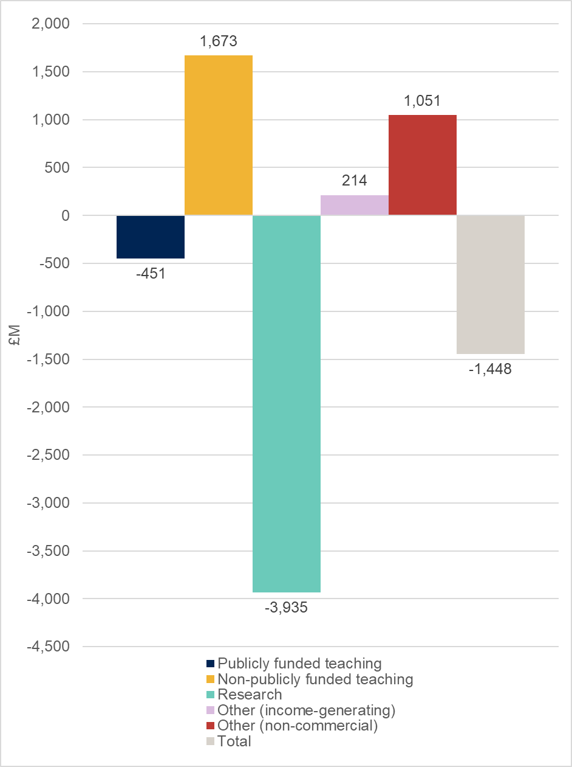

- Table 2 provides further analysis of research income and costs, analysed by research sponsor type. This shows that:
  - Research council funded research activity accounted for 20.1 per cent of total research costs with a recovery of 73.7 per cent of full economic cost, compared with 71.7 per cent in 2017-18.
  - Cost recovery on ‘Training and supervision of postgraduate research students’ continues to show the lowest recovery across the externally sponsored research activity, at 45.1 per cent. Postgraduate full-time equivalent student numbers, as reported in TRAC, increased by 1.7 per cent from 79,925 to 81,280.
  - Quality-related research funding from Research England (RE) or Department for the Economy (Northern Ireland) (DfENI), available to support all ‘public good’ research, totalled £1,669 million.
  - Recovery of costs from ‘other government departments’ was 74.5 per cent, representing a reduction in recovery from the 77.6 per cent cost recovery for 2017-18. Cost recovery from UK charities reduced from 60.4 per cent to 58.7 per cent whilst cost recovery on ‘Industry-sponsored’ research activity (including research funded by overseas government bodies and overseas charities) was in line with the previous year at 77.6 per cent.
- In line with previous years, the sector continues to have a substantial level of activity that does not recover its full costs.
- UK sector aggregate data is provided in Tables 4, 5 and 6 at Annex B.
- Further analysis for the UK sector summarised by peer group is provided as an Excel workbook (see Annex C).

Table 2: Research income and costs by sponsor type, 2018-19 (higher education institutions in England and Northern Ireland) (figures in £M)
 | Recurrent research funding from RE/ DfENI | Institution own-funded | Training and supervision of postgraduate research students | Research Councils | Other government departments | EU | UK charities | Industry | Total research
Income | 1,669 | 496 | 1,069 | 1,907 | 946 | 654 | 1,094 | 1,115 | 8,950
TRAC full economic costs |  | 2,352 | 2,372 | 2,589 | 1,269 | 1,002 | 1,865 | 1,437 | 12,885
Surplus/(deficit) |  | (1,856) | (1,303) | (682) | (323) | (347) | (771) | (322) | (3,935)
Surplus/(deficit) as % of income |  | (374.0)% | (121.9)% | (35.7)% | (34.2)% | (53.1)% | (70.4)% | (28.9)% | (44.0)%
Recovery of full economic costs % |  | 21.1% | 45.1% | 73.7% | 74.5% | 65.3% | 58.7% | 77.6% | 69.5%
Recovery of full economic costs % (2017-18) |  | 16.8% | 47.0% | 71.7% | 77.6% | 65.1% | 60.4% | 77.7% | 69.4%
Included in income
New endowments received | 3 | 63 | 4 | 0 | 0 | 0 | 1 | 5 | 75
New donations | 0 | 45 | 55 | 2 | 1 | 0 | 4 | 61 | 166
New government capital grants | 5 | 93 | 64 | 50 | 22 | 13 | 9 | 6 | 262
New non-government capital grants | 0 | 1 | 2 | 9 | 2 | 3 | 16 | 5 | 38
Other material items | 0 | 25 | 0 | 0 | 0 | 0 | 0 | 0 | 25
Total income items | 8 | 227 | 124 | 61 | 25 | 16 | 30 | 76 | 567
Total as % of income | 0.5% | 45.7% | 11.6% | 3.2% | 2.6% | 2.4% | 2.7% | 6.8% | 6.3%
Total as % of income (2017-18) | 3.4% | 38.5% | 3.1% | 4.2% | 4.4% | 2.5% | 2.8% | 7.8% | 5.6%

Notes to Table 2
- ‘European Union’ covers EU government bodies including the Commission.
- ‘Industry’ includes all other organisations such as UK industry, commerce and public corporations, EU non-government organisations (comprising EU-based charities, EU industry and any other EU source), overseas charities, overseas industry and other sources.

Annex A: Derivations

Table 3: Derivation of Transparent Approach to Costing (TRAC) full economic costs and TRAC surplus/(deficit) for higher education institutions in England and Northern Ireland
 | Total (£M)
Total income adjusted for TRAC (derived from financial statements for 2018-19) | 35,494
Total expenditure adjusted for TRAC (derived from financial statements for 2018-19) | 33,719
TRAC-adjusted operating surplus/(deficit) per audited financial statements | 1,775
Sustainability adjustment (EBITDA for MSI) | 3,222
Full economic cost (total expenditure plus the sustainability adjustment) | 36,942
TRAC surplus/(deficit) | (1,448)

Notes to Table 3
- The income and expenditure lines as reported in the financial statements are adjusted, where appropriate, in respect of pension costs, gains or losses on disposal of fixed assets, gains or losses on investments, share of surpluses or deficits in joint ventures and associates, taxation charges or credits and non-controlling interests, in line with the TRAC guidance for 2018-19 – Version 2.4 (July 2019) and Annual TRAC return template at Annex 4.1a.
- The sustainability adjustment is defined as ‘earnings before interest, tax, depreciation and amortisation’ (EBITDA), adjusted as defined in the TRAC guidance requirements (section 3.2.4 and template at Annex 3.2a) to provide the ‘margin for sustainability and investment’ (‘EBITDA for MSI’).
- Full economic cost is total expenditure derived from the financial statements, plus the sustainability adjustment.
- TRAC surplus/(deficit) is the difference between total income and the full economic costs.

Annex B: UK sector data summary

Table 4: Transparent Approach to Costing (TRAC) income and full economic costs by activity, 2018-19 (UK higher education institutions) (figures in £M)
 | Publicly funded teaching | Non-publicly funded teaching | Research | Other (income- generating) | Other  (non-commercial) | Total
Income | 15,547 | 6,469 | 10,714 | 6,938 | 1,610 | 41,279
TRAC full economic costs | 16,158 | 4,512 | 15,166 | 6,652 | 469 | 42,956
Surplus/(deficit) | (611) | 1,958 | (4,451) | 286 | 1,141 | (1,677)
Surplus/(deficit) as % of income | (3.9)% | 30.3% | (41.5)% | 4.1% | 70.9% | (4.1)%
Recovery of full economic costs % | 96.2% | 143.4% | 70.6% | 104.3% | 343.5% | 96.1%
Recovery of full economic costs % (2017-18) | 97.9% | 139.4% | 70.0% | 103.7% | 373.0% | 95.7%
Included in income
New endowments received | 5 | 49 | 78 | 2 | 31 | 165
New donations | 36 | 47 | 167 | 5 | 167 | 422
New government capital grants | 86 | 17 | 389 | 25 | 25 | 543
New non-government capital grants | 19 | 8 | 62 | 20 | 24 | 133
Other material items | 3 | 1 | 1 | 16 | 23 | 43
Total income items | 149 | 122 | 697 | 68 | 270 | 1,306
Total as % of income | 1.0% | 1.9% | 6.5% | 1.0% | 16.8% | 3.2%
Total as % of income (2017-18) | 0.9% | 2.0% | 5.3% | 1.3% | 13.3% | 2.7%

Figure 2: TRAC full economic cost surplus/deficit by activity, 2018-19 (UK higher education institutions)
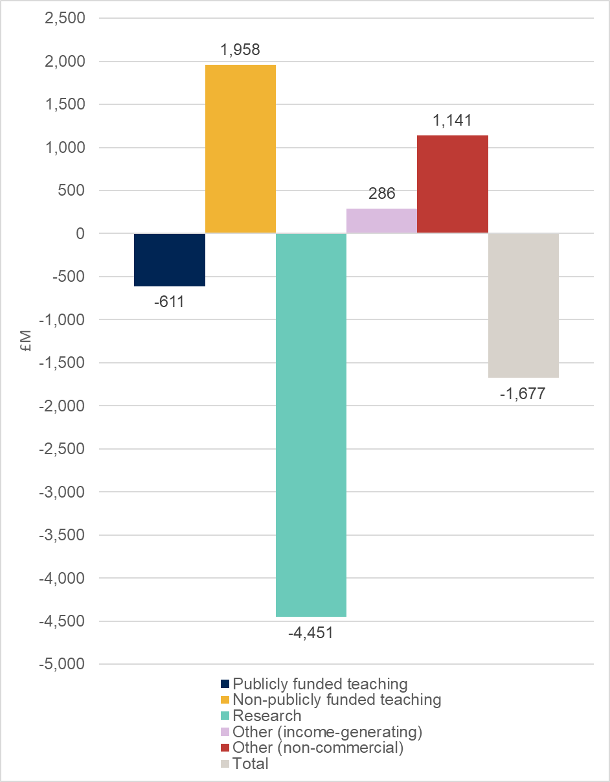

Definitions for Table 4 and Figure 2
Publicly funded teaching: Teaching of higher and further education courses to home and EU students who were fundable by the OfS, Scottish Funding Council, Higher Education Funding Council for Wales or the Department for the Economy (Northern Ireland) or by the NHS, National College of Teaching and Leadership, or Education and Skills Funding Agency. Income includes student fees paid via the Student Loans Company.
Non-publicly funded teaching: Teaching of students from outside the UK and EU; self-funded home and EU students and other commissioned courses (such as employer-specific ‘closed’ courses).
Research: All research activity (but not scholarship or staff development) commissioned and funded by external sponsors, or the institution’s own-funded research activity. Public sponsors of research include UK research councils and other government departments. Other sponsors include UK charities, the EU, overseas governments, overseas charities and research carried out for commercial or industrial sponsors.
Other (income-generating): Includes commercial activities such as catering and conferences, commercially let facilities and residences; activities carried out through subsidiary companies such as publishing or commercial consultancy; knowledge transfer activity; and, for institutions with medical and dental schools, services provided to the NHS.
Other (non-commercial): Non-commercial activity such as investment and donations or endowments.

Table 5: Research income and costs by sponsor type, 2018-19 (UK higher education institutions) (figures in £M)
 | Recurrent research funding from UK higher education funding bodies/RE | Institution own-funded | Training and supervision of postgraduate research students | Research Councils | Other government departments | EU | UK charities | Industry | Total research
Income | 2,021 | 561 | 1,249 | 2,286 | 1,154 | 841 | 1,312 | 1,290 | 10,714
TRAC full economic costs |  | 2,680 | 2,762 | 3,088 | 1,541 | 1,220 | 2,204 | 1,670 | 15,166
Surplus/(deficit) |  | (2,120) | (1,513) | (801) | (387) | (380) | (892) | (380) | (4,451)
Surplus/(deficit) as % of income |  | (378.1)% | (121.2)% | (35.0)% | (33.5)% | (45.1)% | (68.0)% | (29.5)% | (41.5)%
Recovery of full economic costs % |  | 20.9% | 45.2% | 74.0% | 74.9% | 68.9% | 59.5% | 77.2% | 70.6%
Recovery of full economic costs % (2017-18) |  | 17.1% | 46.4% | 71.9% | 76.9% | 65.9% | 60.5% | 76.6% | 70.0%
Included in income
New endowments received | 3 | 63 | 4 | 0 | 0 | 0 | 2 | 5 | 78
New donations | 0 | 45 | 55 | 2 | 1 | 0 | 4 | 61 | 167
New government capital grants | 5 | 109 | 70 | 69 | 26 | 53 | 20 | 12 | 364
New non-government capital grants | 0 | 3 | 4 | 22 | 3 | 5 | 18 | 7 | 62
Other material items | 0 | 25 | 0 | 0 | 0 | 0 | 0 | 0 | 26
Total income items | 8 | 245 | 133 | 93 | 31 | 59 | 44 | 85 | 697
Total as % of income | 0.4% | 43.6% | 10.6% | 4.1% | 2.7% | 7.0% | 3.4% | 6.6% | 6.5%
Total as % of income (2017-18) | 2.8% | 37.6% | 3.1% | 4.2% | 4.0% | 2.9% | 2.9% | 7.2% | 5.3%

Notes to Table 5
- ‘European Union’ covers EU government bodies including the Commission.
- ‘Industry’ includes all other organisations such as UK industry, commerce and public corporations, EU non-government organisations (comprising EU-based charities, EU industry and any other EU source), overseas charities, overseas industry and other sources.

Table 6: Derivation of Transparent Approach to Costing (TRAC) full economic costs and TRAC surplus/(deficit) (UK higher education institutions)
 | Total (£M)
Total income adjusted for TRAC (derived from financial statements for 2018-19) | 41,279
Total expenditure adjusted for TRAC (derived from financial statements for 2018-19) | 39,380
TRAC-adjusted operating surplus/(deficit) | 1,899
Sustainability adjustment (EBITDA for MSI) | 3,576
Full economic cost (total expenditure plus the sustainability adjustment) | 42,956
TRAC surplus/(deficit) | (1,677)

Notes to Table 6
- The income and expenditure lines as reported in the financial statements are adjusted, where appropriate, in respect of pension costs, gains or losses on disposal of fixed assets, gains or losses on investments, share of surpluses or deficits in joint ventures and associates, taxation charges or credits and non-controlling interests, in line with the TRAC guidance for 2018-19 – Version 2.4 (July 2019) and Annual TRAC return template (Annex 4.1a).
- The sustainability adjustment is defined as ‘earnings before interest, tax, depreciation and amortisation’ (EBITDA), adjusted as defined in the TRAC guidance requirements (section 3.2.4 and template at Annex 3.2a) to provide the ‘margin for sustainability and investment’ (‘EBITDA for MSI’).
- Full economic cost is total expenditure derived from the financial statements, plus the sustainability adjustment.
- TRAC surplus/(deficit) is the difference between total income and the full economic costs.

Annex C: UK peer group summary 2018-19
- Sector peer group summary is provided as an Excel file. The Excel workbook contains three worksheets of data:
- Tables 1 and 2 provide analysis of TRAC full economic costs and cost recovery on the main activities, analysed by TRAC peer group
- Table 3 provides recovery of full economic costs for research, by research sponsor type, analysed by TRAC peer group
- Table 4 provides analysis of the sustainability adjustment and TRAC surplus/(deficit).

Analysis by TRAC peer group: methodology
- The worksheets provide summary data (averages, medians and quartiles) for the UK sector and each of the TRAC peer groups (groups A to F), including charts.
- Higher education institutions have been allocated to TRAC peer groups based on levels of research income, overall total income, having a medical school, or specialism in music or the arts. TRAC peer groups are set for a number of years in order to maintain a stable group for comparison, and so are not updated annually. They will next be updated for 2019-20 TRAC reporting.
- When considering the analysis in the peer group tables, the number of institutions with data in each peer group should be taken into consideration; these are shown at the top of each table.
- In all tables, the ‘UK sector’ has been split into three categories: All institutions; those not applying dispensation; and those applying dispensation. For individual peer groups, all institutions are included, whether dispensation has been applied or not. This is a change from 2017-18 (and earlier) TRAC analysis, where the data shown for 'UK sector' and individual peer groups excluded institutions that applied dispensation.

© The Office for Students copyright 2020
This publication is available under the Open Government Licence 3.0 except where it indicates that the copyright for images or text is owned elsewhere.
www.nationalarchives.gov.uk/doc/open-government-licence/version/3/

For the purposes of this publication, higher education institutions are those institutions that were previously funded by the Higher Education Funding Council for England (HEFCE) and were required to submit annual TRAC returns to the Office for Students for 2018-19; and higher education institutions funded by the Scottish Funding Council (SFC), Higher Education Funding Council for Wales (HEFCW) and the Department for the Economy (Northern Ireland).
The analysis is based on: 133 higher education institutions that were previously funded by HEFCE in 2017-18 and are now funded by the Office for Students, and one provider that implemented TRAC for 2018-19 reporting; and two higher education institutions funded by the Department for the Economy, Northern Ireland.
Available at: www.officeforstudents.org.uk/data-and-analysis/trac-data/published-data-2018-19/.
TRAC full economic costs comprise the total expenditure from audited financial statements plus the sustainability adjustment: the margin for sustainability and investment (MSI).
The TRAC methodology makes adjustment to exclude the costs or credits attributable to the agreement of a deficit recovery plan for certain specific multi-employer defined benefit pension schemes, including the Universities Superannuation Scheme (USS), in order to avoid the potential distorting effect of large charges (and potential credits) caused by triennial reassessment of multi-employer pension scheme recovery plans (such as the USS, the Superannuation Arrangements for the University of London (SAUL) and University of Oxford Staff Pension Scheme (OSPS)). This is addressed by replacing the financial accounting charges with the annual cash contributions (which include deficit contributions) to the pension scheme in question. The FRS102 accounting for USS, SAUL and OSPS is different to other defined benefit pension schemes, which is why this adjustment is necessary for these schemes but not for other defined benefit schemes.
Definitions for this table can be found on page 4. Figures in this and subsequent tables may not sum because of rounding.
Data does not include postgraduate students at institutions that apply dispensation from the TRAC requirements.
The TRAC guidance is available at www.trac.ac.uk/tracguidance/.
1¹ The TRAC guidance is available at www.trac.ac.uk/tracguidance/.
Available at www.officeforstudents.org.uk/data-and-analysis/trac-data/published-data-2018-19/.
A list of higher education institutions and the criteria used in defining each peer group can be found at Annex 4.1b of the TRAC guidance, available at: www.trac.ac.uk/tracguidance/.

